


Westmorland and Furness Emotionally Based School Avoidance Support Plan

westmorlandandfurness.gov.uk June 2023

‘Emotionally Based School Avoidance (EBSA) is a broad umbrella term used to describe a group of children and young people who have severe difficulty in attending school due to emotional factors, often resulting in prolonged absences from school’
(West Sussex County Council, 2022)

At times EBSA is also referred to as Emotionally based school non-attendance (EBSnA).

The attached support plan can be used by schools, with or without input from other agencies, to provide a framework for planning and implementing interventions for students who show Emotionally Based School Avoidance.

The plan follows a framework of ‘assess, plan, do review’
Assess: Several tools are suggested for gathering information from students, families and staff. There is no expectation that all of these are used. Choose the ones that seem most appropriate to the situation and consider any other information already available. Your school Educational Psychologist may be able to help with other assessment tools if needed.

Plan: Planning begins with formulation about the possible functions of the school avoidance behaviour.
Key functions identified in research include:

- To avoid uncomfortable feeling brought on by attending school
- To avoid stressful situations
- To reduce separation anxiety
- To pursue reinforcers outside school

Plans should be coproduced with input from schools, families, young people, and other agencies if they are involved.

Do: The plan provides space to record the next steps that have been agreed, any interventions that might be needed, and more general strategies to support the student’s attendance. These supports are agreed by all parties at a planning meeting. Flexibility of response based on individual circumstances and functions is key.

Review: The plan should be reviewed and adjusted frequently. Initially this may need to be at least every 2-4 weeks. If needed, other agencies can be involved in supporting development of the plan for example, Educational Psychologists, Specialist Teachers, Access and Inclusion Officers, Mental Health Professionals, other Health Professionals, Alternative Provisions, or agencies working with families at home.

If you require support with using the plan, please contact your school Educational Psychologist.

This plan was developed by the Cumbria County Psychological Service (now Westmorland and Furness and Cumberland Councils), with input from the Cumbria Multiagency Emotionally Based School Avoidance Steering Group. In producing the plan, we have drawn on previous work by West Sussex Educational Psychology Service, Sheffield Educational Psychology Service and Lancashire Educational Psychology Service. We are grateful to all these colleagues for their insights.

EBSA Access to Education Support Plan

Name: | DOB:
School: | Person writing plan

Background e.g. health, learning or social needs

Other agencies involved

Pupil Voice: list the tools used to gather the pupil’s views: see appendix 1. Note key points

Family Voice: who met with the family to gather their views and when? See appendix 2. Note key points

Views of Key Staff: which staff in school have been consulted? See appendix 3. Note key points

Description of behaviour in school: including when it first occurred, what is the current rate of
attendance? Are there any patterns? What does the behaviour look like?
Outside School: Does the pupil attend any extracurricular activities? Do they go out with their family - if so, where and with whom? What does the behaviour look like at home?
What Strengths and Protective Factors have been identified? For example, aspirations or ambitions, positive relationships at home and school, positive experiences at school, what worked/was helpful in the past? Are there times when things are better – and why?
What is the function of the behaviour? (there may be more than one function)
- To avoid something or situations that elicit negative feelings or high levels of stress (e.g. fear of the toilets, playground noise, busy corridors, tests/exams).
- To escape difficult social situations (e.g. feeling left out at playtime, reading out loud in class, public
speaking, working as a group).
- To get attention from or spend more time with significant others (e.g. change in family dynamic,
concerned about the well-being of a parent).
- To spend more time out of school as it is more fun or stimulating (e.g. shopping, playing computer games, spending time with friends).

What ideas are there about why this behaviour is happening? List them here

•

•

•

Action Plan

Name: | Year group:
Key adult: | Safe place:
Date of Plan: | Date of Next Review:
Regular communication between home and school will take place: When? Who? How?
List key areas to work on identified by assessments: for example, peer/adult relationships, anxiety, attachment issues, learning difficulties, access strategies, sensory issues, transitions, morning routines, sleep, out of school activities. There may be others….
What next steps have we agreed with the child? What is a realistic expectation given the starting point? Be careful…’targets’ could create pressure and if not achieved could lead to increased anxiety. Consider using the ladder template – appendix 4
•

•

•
What actions will we take to achieve this and what strategies will we use? Include actions for school and home

What general strategies can we use? Things that staff and other students can do/not do to help the pupil feel better in school. Things the pupil can do to help themselves feel better. What to do if the pupil appears anxious or if staff notice difficulties.
Do we need to involve any other people to help us and if so what support do we want from them?
Review of Progress
People involved in writing this plan

If needed, guidance on the use of part time timetables can be found here: https://content.govdelivery.com/attachments/UKCCC/2021/03/25/file_attachments/1734506/ Guidance%20for%20schools%20on%20the%20use%20of%20part%20time%20timetables%20 and%20reporting.docx

Appendix 1: Strategies for Gaining Pupil Voice

Timetable review
A tool often used by adults working with students showing school anxiety is to offer CYP the opportunity to review their timetable and places around school, identifying which lessons and areas are associated with a lot, some, or no anxiety. Using a red, amber and green anxiety code may help. Bear in mind
that some CYP may experience anxiety just by thinking about some lessons / lunchtimes / break times / transition to or from school and may need the support of an empathetic adult during this activity Exploration of the issues arising from this can provide useful information.

Anxiety thermometer or scale
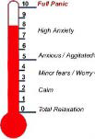
Using an anxiety thermometer or scale can help the young person to start to make links between their emotions and environmental/contextual triggers. Consider the physical environment (toilets, hall, corridors, changing rooms,
outside), times of day (arrival, home time, break and dinner times) and specific lessons and activities (reading aloud, group work, writing, tests). Using a map of the school building can be helpful when exploring the impact of the physical environment on their anxiety.

Card Sort: Function of School Avoidance
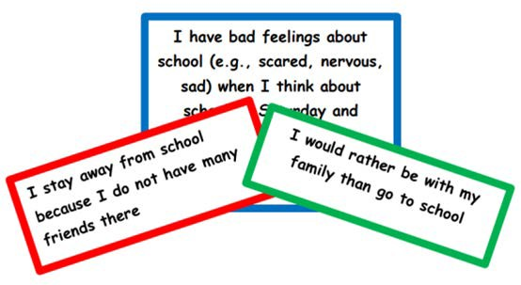
This card sort activity, based on a School Refusal Assessment Scale developed by Kearney (2002), has been devised by Sheffield EPS as a tool for staff to use to develop a greater understanding of a young person’s school avoidance. The 24 statements are colour-coded by the function of behaviour identified by Kearney and Silverman (1990). The cards and guidance on how to use are available from the EP Service.

Ideal Classroom/School
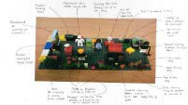
This tool developed by Williams and Hanke (2007) can be used to gain an insight into which features of the school (people, environment, lessons etc.) young people would like to change and why. This activity can be undertaken using Lego, play equipment and/or drawing. There is a presentation on drawing the ideal school here with further information about Personal Construct Psychology:

www.ucl.ac.uk/educational-psychology/new_site/resources/JaneWilliams_
DECP2016conference.pdf

School Stress Survey

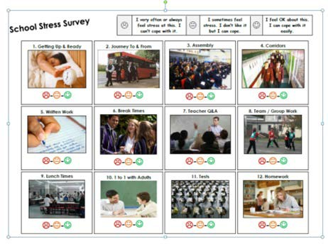
This short survey can be used to help the young person identify potential triggers in the school day and environment. The full survey can be found at:
https://www.tes.com/teaching-resource/school-stress-
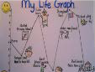
survey-6386627

Life Graph
Collaboratively developing a life graph or path with the young person may help them to consider when their EBSA started, what else was happening in their lives at this time, what events and experiences led up to this point and how they interpreted these, as well as looking at what they would want in the future.

5 point scale
The 5 point scale already used in many schools can be used as a way of supporting CYP to understand and manage overwhelming feelings. It can be used with CYP
5
4
3
2
1

of all ages and begins with an exploration of emotions. CYP can then use the scale to describe how they are feeling, and what these feelings may look or sound like; they can explore situations that may make them feel a certain way and move to describing how to reduce overwhelming or difficult emotions. The scales that the CYP makes can be used as a communication tool for example, making into a
keyring or using different coloured cards or bracelets to let adults know that they feel
a certain way.
There are free downloadable resources available at https://www.5pointscale.com/

Externalisation
It can sometimes be helpful to support the CYP to externalise the anxiety, so that the CYP can start to view their anxiety as separate from their essential self. This is a great opportunity to get creative and have fun using paints, playdough, clay and collage materials as you explore the anxiety with the CYP. You could try asking:
- What would you call the feeling you have when you think about going to school?
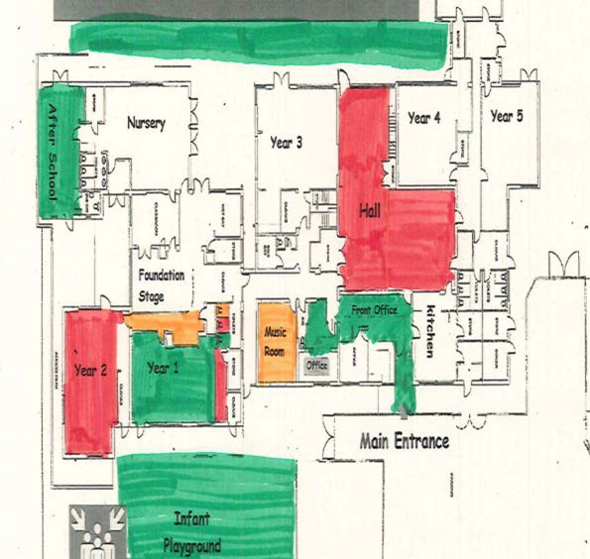
- If your anxiety was a ‘thing’, what would it look like?
- Can you draw/paint/make it? What would it say?
- How does … get in the way of you coming to school?
- When is … in charge and when are you in charge?

Sensory Aspects of School
Some children find that noises, busy environments, visual experiences, smells or tactile sensations can lead to anxiety and sensory overload. After talking about their senses (using age-appropriate resources) try RAG rating different areas/rooms/lessons in school from a sensory perspective. Note any likes and any experiences or areas that they find hard.
There is a general sensory checklist here: 37.2-Sensory-assessment-checklist.pdf (positiveaboutautism.co.uk) but try to obtain information from the young person’s perspective. Training on sensory needs is available here: Lancashire and Cumbria Sensory Education Session
| Cumbria’s Family Information Directory

Appendix 2: Gaining Parental Views

Theme | Possible questions
Family dynamics  It can be helpful to gain an understanding the young person’s life journey and significant events which may have impacted upon their lived experiences. | - Could you describe your family? Or draw your family tree?  - Who is X closest to in the family? Has this always been the case?  - Have there been any changes within the family recently? Or are there  any upcoming changes in the near future?  - Was anything different in your family at the time that you noticed X’s difficulties increasing?  - Have there been any significant life events that X has experienced? Or  any important losses/bereavements/long-term illness?
Strengths, interests and aspirations | - What is X good at? What do they like doing?  - Do they have any hopes for the future? Do they know what they want their life to be like when they are an adult?
Developmental and educational history | - What was X like as a young child?  - Can you tell me about their early experiences at school? The primary school, at the start of secondary school?
Relationships | - Does X talk about any other children? What does s/he say?  - Does X talk about any adults within school? What does s/he say?  - Who does X get on with…who doesn’t X get on with?  - Does X interact with other students out of school?  - Which friendship groups are significant?
Academic progress | - School should be aware if the young person has identified SEN needs  and should ask about these needs and the support in place.  - If there is no identified SEN school should ask if they have any concerns, or if the child has spoken about difficulties.
Behaviour and symptoms of anxiety | - When X is worried what does it look like?  - What do they say they are feeling?  - Is X’s sleeping and eating affected?
The child’s view – fears and worries | - Has X spoken to you about what X finds difficult about school? What do  they say?
The child’s view – going well in school | - Has X mentioned anything that is going well in school? (e.g. teachers,  lessons, friends)
Typical day | - What does a typical day look like for X / yourself when they do/do not attend school?  - Take me through it, what happens from the moment they wake, to the moment they sleep…

Theme | Possible questions
Parental views on the reasons for EBSA | - Why do you think X has difficulty attending school? (ask each parent  separately)  - If (other parent/ sibling/Grandparent) were here what would they say?  - Are there any differences of views about the reasons and what should  be done within the family?
Exceptions  These questions can help shift the focus away from the  presenting problem, to consider aspects within a situation which are working well or supporting the young person not to get worse. | - Tell me about the times when X is not feeling X  - Tell me about the times when X is feeling less X  - Tell me about the times when X has coped well  - Tell me about the days/times of day when you think something has gone  well for X. What is different during these times?  - Tell me about the times when X has managed to go to school. What  was different about these times?  - Tell me what other people have done that has been useful/helpful for X.

Appendix 3: Views of School Staff

Name of young person
Your name and role
Strengths
What is going well?
Difficulties
What things do they find difficult? Have you observed any emotional difficulties?
Response to academic tasks Are they engaged and motivated with their learning?
Are they making progress? If not, why do you think this may be?
Relationships with peers and adults
How do they get on with adults
and their friends/ other peers
Support
What support do you provide? How do they respond to this support?
Reasons
What is your understanding of their attendance problems?
Further support
Have you got any ideas for further support? What do you think would help in school?

CCCJ/N 25666
Appendix 4: Avoidance Hierarchy
Construct a ladder of places or situations that you avoid. At the top of the ladder put those which make you most anxious. AT the bottom of the ladder put places or situations you avoid, but which don’t bother you as much. In the middle of the ladder put places or situations you avoid, but which don’t bother you as much. In the middle of the ladder put ones that are ‘in-between’. Give each item a rating from 0 - 100% according to how anxious you would feel if you had to be in that situation. Overcome your anxiety by approaching these situations, starting from the bottom of the ladder.

Situation Anxiety (1-100%)

