Appendix 2 – County Council Accident Incident Form (template example)
The front page of the form is shown below as an example. The latest versions (both electronic and print and complete) can be accessed via the School Portal. Reference Library (All documents) – Health and Safety – Accident Reporting and Recording.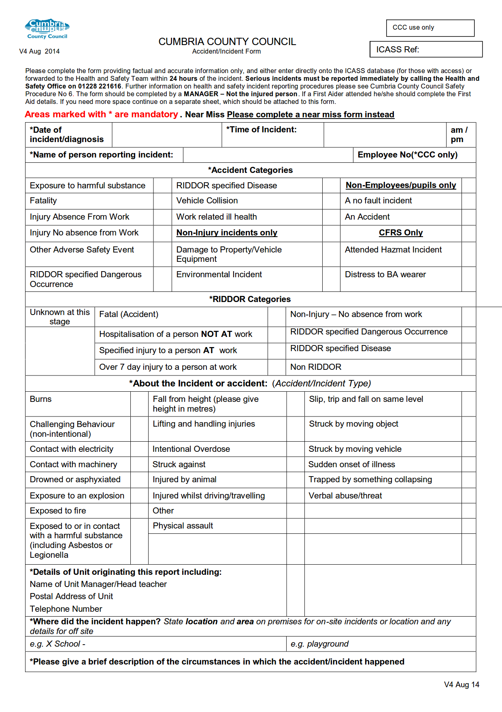
V5

